Bank Account

Name : Abdulrahman Salah anwer

**The account class**

package Assignment5;  
  
import java.util.ArrayList;  
import java.util.Date;  
  
public class Account {  
 protected String name ;  
 protected int id ;  
 protected double balance ;  
 private double annualInterestRate ;  
 private Date dateCreated ;  
 private ArrayList<Transaction> transactions ;  
  
 public Account() {  
 this.name = "" ;  
 this.id = 0 ;  
 this.balance = 0 ;  
 this.annualInterestRate = 0 ;  
 }  
  
 public Account(String *name* , int *id* , double *balance* , double *annualInterestRate* ){  
 this.name = *name* ;  
 this.id = *id* ;  
 this.balance = *balance* ;  
 this.annualInterestRate = *annualInterestRate* ;  
 this.transactions = new ArrayList<>();  
  
 dateCreated = new Date();  
 }  
 public boolean withdraw(double *amount* ){  
 if(balance < *amount*) return false;  
 balance -= *amount* ;  
 this.transactions.add(new Transaction('w',*amount*,this.balance,"withdrawn"+*amount*));  
 return true;  
 }  
 public void deposit(double *amount* ){  
 balance += *amount* ;  
 this.transactions.add(new Transaction('D',*amount*,this.balance,"deposited"+ *amount*));  
 }  
  
 public int getId() {  
 return id;  
 }  
  
 public void setId(int *id*) {  
 this.id = *id*;  
 }  
  
 public double getBalance() {  
 return balance;  
 }  
  
 public void setBalance(double *balance*) {  
 this.balance = *balance*;  
 }  
  
 public double getAnnualInterestRate() {  
 return annualInterestRate;  
 }  
  
 public void setAnnualInterestRate(double *annualInterestRate*) {  
 this.annualInterestRate = *annualInterestRate*;  
 }  
  
 public Date getDateCreated() {  
 return dateCreated;  
 }  
  
 public String getName() {  
 return name;  
 }  
  
 public void setName(String *name*) {  
 this.name = *name*;  
 }  
  
 public ArrayList<Transaction> getTransactions() {  
 return transactions;  
 }  
  
  
 public String toString() {  
 return "Account{" +  
 "name='" + name +  
 ", id=" + id +  
 ", balance=" + balance +  
 ", annualInterestRate=" + annualInterestRate +  
 ", dateCreated=" + dateCreated +  
 ", \n transactions=" +getTransactions() +  
 '}';  
 }  
  
}

**Transaction class**

package Assignment5;  
  
import java.util.Date;  
  
public class Transaction {  
 private Date;  
 private char type; // w or d  
 private double amount ;  
 private double balance ;  
 private String description ;  
 public Transaction(char *type*, double *amount*, double *balance*, String *description*) {  
 this.type = *type*;  
 this.amount = *amount*;  
 this.balance = *balance*;  
 this.description = *description*;  
  
 this.date = new Date();  
 }  
  
 *@Override* public String toString() {  
 return "\nTransaction{" +  
 "date=" + date +  
 ", type=" + type +  
 ", amount=" + amount +  
 ", balance=" + balance +  
 ", description='" + description + '\'' +  
 '}';  
 }  
}

**checking Account class**

package Assignment5;  
  
public class CheckingAccount extends Account {  
  
 protected double OVERDRAFT_LIMIT = -100;  
  
 public CheckingAccount(double *OVERDRAFT_LIMIT*) {  
 this.OVERDRAFT_LIMIT = *OVERDRAFT_LIMIT*;  
 }  
  
 public CheckingAccount(String *name*, int *id*, double *balance*, double *annualInterestRate*, double *OVERDRAFT_LIMIT*) {  
 super(*name*, *id*, *balance*, *annualInterestRate*);  
 this.OVERDRAFT_LIMIT = *OVERDRAFT_LIMIT*;  
 }  
  
 *@Override* public boolean withdraw(double *amount*) {  
 if (balance - *amount* >= OVERDRAFT_LIMIT) {  
 super.withdraw(*amount*);  
 }  
 return false;  
 }  
  
 *@Override* public String toString() {  
 return super.toString() +  
 " OVERDRAFT_LIMIT=" + OVERDRAFT_LIMIT +  
 '}';  
 }  
}

**Saving Account class**

package Assignment5;  
  
  
public class SavingsAccount extends Account {  
  
 protected double OVERDRAFT_LIMIT = 0;  
  
 public SavingsAccount(double *OVERDRAFT_LIMIT*) {  
 this.OVERDRAFT_LIMIT = *OVERDRAFT_LIMIT*;  
 }  
  
 public SavingsAccount(String *name*, int *id*, double *balance*, double *annualInterestRate*, double *OVERDRAFT_LIMIT*) {  
 super(*name*, *id*, *balance*, *annualInterestRate*);  
 this.OVERDRAFT_LIMIT = *OVERDRAFT_LIMIT*;  
 }  
  
 *@Override* public boolean withdraw(double *amount*) {  
 if (balance - *amount* >= OVERDRAFT_LIMIT) {  
 super.withdraw(*amount*);  
 }  
 return false;  
 }  
  
 *@Override* public String toString() {  
 return super.toString() +  
 " OVERDRAFT_LIMIT=" + OVERDRAFT_LIMIT +  
 '}';  
 }  
}

**Test class (main)**

package Assignment5;  
  
public class test{  
  
 public static void main(String[] *args*){  
 Account = new Account("Sara",1122,1000,1.5);  
 CheckingAccount = new CheckingAccount("Sara",1122,1000,1.5,-5000);  
 SavingsAccount savingsAccount = new SavingsAccount("Sara",1122,1000,1.5,0);  
 System.out.println(account);  
 System.out.println(checkingAccount);  
 System.out.println(savingsAccount);  
 account.toString();  
 checkingAccount.toString();  
 savingsAccount.toString();  
 account.deposit(30);  
 account.deposit(40);  
 account.deposit(50);  
 account.withdraw(5);  
 account.withdraw(4);  
 account.withdraw(2);  
 System.out.println(account.toString());  
 }  
}

**The output**

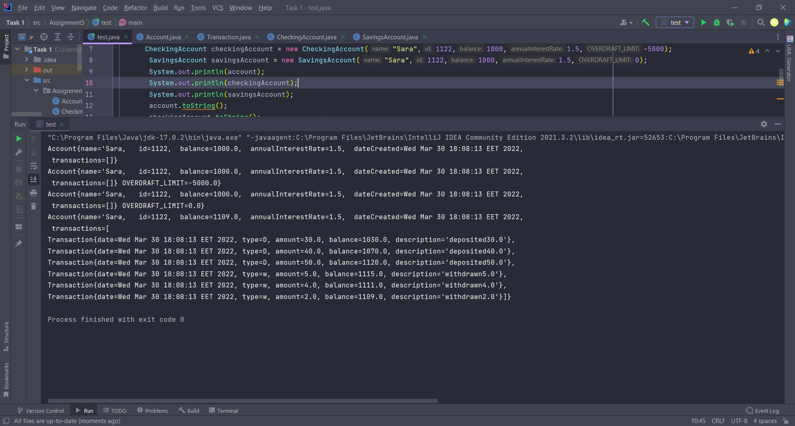

**UML**

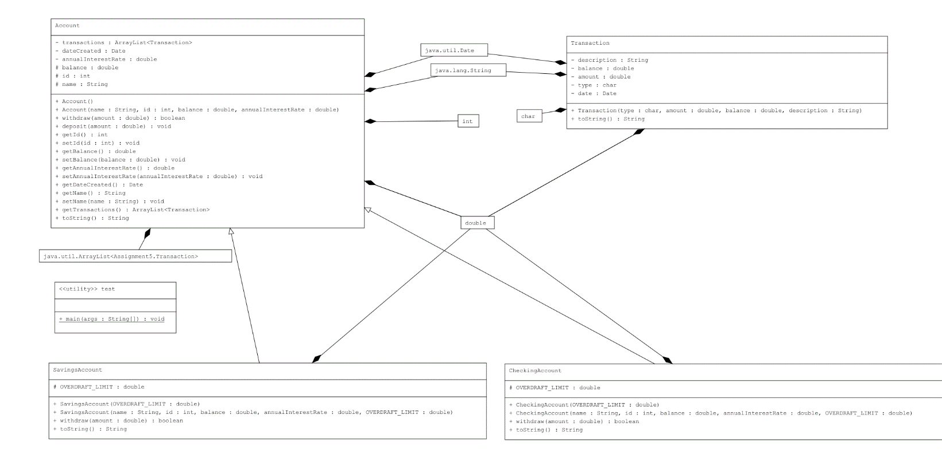

Done …